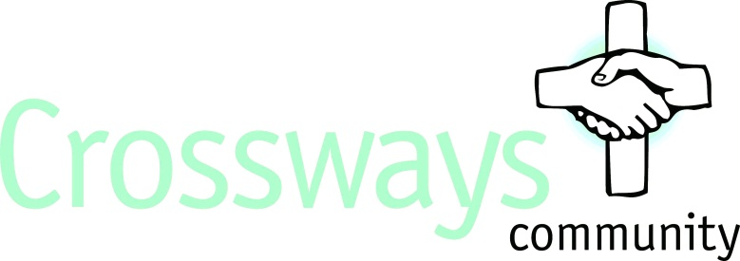

Job Description - Cleaner

Post Title - Cleaner

About us - Crossways Community is a Christian charity with a passion to see better mental health in its community. We have a proven track record in providing residential care and support for adults with acute mental health issues, giving residents valuable life skills and work experience and promoting awareness of mental health issues within schools, churches and the local community.
We are now looking for a cleaner to join us at this exciting time for Crossways.

Purpose of the job - Ensuring we provide a clean environment for our residents and staff by providing a high-quality cleaning service and high standards of cleanliness

Main duties of the post

- To be responsible for general cleanliness of Moxham House with appropriate record keeping
- To carry out all cleaning duties as directed by the Manager to the required standard
- To carry out deep cleaning schedule as defined by the Manager with appropriate record keeping
- To be responsible for maintaining stock levels of cleaning products
- To be responsible for COSHH data sheets for cleaning products and to comply with COSHH regulations.
- To clean other areas of Crossways, including where requested, residents’ personal bedrooms, bathrooms or shower rooms.
- To be aware of relevant policies and procedures of Moxham House
- To respond to emergency situations in accordance with Moxham House policies regarding fire and accidents, determining and taking appropriate action
- To be aware of the health and safety regulations, reporting any hazards or defects to furnishings and equipment to the Manager
- To be aware of risk assessments on the structure, fabric and environment of Crossways
- To attend training as defined by Manager including on Safeguarding
- To attend morning handovers
- To be sensitive to the privacy and individual needs of the residents
- To carry out other ad hoc duties as requested by the Manager

Essential Qualities

- Willing to abide by Crossways’ Christian ethos.
- Good English, verbal and written communication skills
- Calm, confident, methodical, patient and flexible, good interpersonal skills, and able to work as part of a team, alone and unsupervised.
- Friendly, polite and caring
- Previous cleaning experience
- Physically fit to undertake the role

Additional information

- Responsible to Manager of Moxham House
- 16.25 hours a week (mornings desirable)
- Salary - £10.39 per hour
- The post will be subject to suitable references and an enhanced DBS check.
- Experience or knowledge of the mental health sector, whilst useful, is not essential
- Primarily based at Moxham House but work may be required occasionally in other parts of Crossways site in Tunbridge Wells

