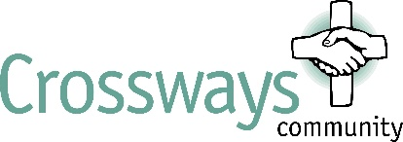
Job Description Moxham House
1.1 To work as a named keyworker with allocated residents to develop and monitor personal care plans so as to encourage residents to participate as fully as possible in the running of the home and the wider community. This will include liaising with other professionals or agencies and accompanying residents on outside activities etc. Sometimes this might involve driving so a full driving licence is required.
1.2 To participate with other staff to encourage and help residents implement their care plan and where appropriate to maintain contact with their family and friends so that they can participate more fully with their care.
1.3 To undertake appropriate recording of information linked to the care of residents (where possible how they have progressed towards their care plan) and other related office work as required in running a large care home.
1.4 To assist and come along-side residents as they take part in the general cleaning and upkeep of their rooms, their personal washing, and other parts of the house.
1.5 To dispense pre-packed medication to residents who require monitoring.

2 Supervision & Training
2.1 To accept and receive support, appraisal and supervision from a senior manager.
2.2 To attend training courses and events as required.
2.3 To seek to use other opportunities to add to and update your training.

3 Policies and Health & Safety
3.1 To be aware of current policies, procedures and the Staff Handbook affecting the running of Crossways.
3.2 To respond to emergency health and safety situations and in accordance with Crossways' policies.
3.3 To be aware of risk assessments of residents in or out of Crossways.
3.4 To help ensure the security of Crossways and be conscious of general security reporting any matters of general concern to the Duty Manager.

4 Practical, Domestic & General Duties
4.1 To be undertake practical duties as required which may include: cooking, general cleaning, maintenance and upkeep of the house, shopping for food or other items required for the house.
4.2 To take and participate in ‘chapel’, daily times of meditation, singing and prayer, and attend bi-monthly mornings of prayer.
4.3 To help prepare and be involved in annual Coffee Morning, Thanksgiving Service, Residents’ party and other such Crossways’ events as appropriate.
4.4 To carry out any other ad hoc duties as required by the Duty Manager.

