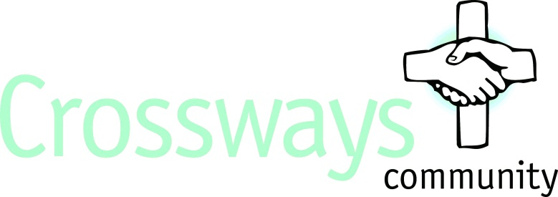

Job Description – Deputy Manager of The Kitchen Table

POST TITLE: Crossways Community Deputy Cafe Manager
REPORTING TO: Crossways Community Cafe Manager
SALARY: £21,012

What would like in a new member of staff?
You will need to be someone who values community experience, life and professionalism, be able to work within and supervise your team in delivering a Community Cafe that provides an environment for conversations about mental health, a place of sanctuary for our residents and an outreach for members of the public who may not be aware of the work at Crossways. You will also need to be someone with whom the team can develop individual relationships. Your influence will include community activities, life skills training and work opportunities. It will help your application if you also possess some or all of the desirable qualities.

Essential Qualities
- Proven ability to undertake the necessary practical skills required to successfully assist in a Cafe/Food business similar in nature to the Crossways’ Community Cafe.
- Ability to lead, manage and work alongside a team of staff and volunteers
- Willing to abide by Crossways’ Christian Ethos
- Ability to deal with emergencies as required
- Ability to deal with, prioritise and plan work
- Ability to work as part of a team and alone unsupervised
- Ability to handle personal stress
- Good communication skills, (verbal & written English) and an ability to keep accurate and timely electronic and paper records.
- A positive attitude to problem solving.
- An open and honest person able to value other people as they are but to also see their potential.
- A love of cooking & people
- Mobility: Ability to climb stairs
- A full UK driving licence
- Satisfactory references including an Enhanced DBS Disclosure

Desirable Qualities
- Experience of supporting people with mental health problems and/or working in a care environment
- Experience of recruiting and training new members of staff
- Experience of working with other organisations
- Having any/all of the following training: Food Safety Training to Level 2 or 3, First Aid, Health & Safety, COSHH.

Summary of Hours of Work
You will be expected to work 37.5 hours a week over 5 days, including a Saturday.
Hours would be 7.30am - 3.30pm.

Purpose of Job
To work in and help manage a Community Cafe on behalf of Crossways which fully complies with both the policies and procedures of Crossways and the legal responsibilities required to operate a safe food retail business to members of the public. As a Crossways ambassador you will be required to be engaged with other staff in support of the physical, social, psychological and spiritual support of adults with mental health problems.

As the Deputy Cafe Manager, working with the Café manager, you will be required to ensure that all the activities necessary to run a Cafe business, including cooking, cleaning, managing a team of staff and volunteers, maintaining safe food practices and Health and Safety of the general public are delivered and maintained. You will assist with Cafe food and drinks purchasing, cash management, daily office and administration duties which surround the management of a team of staff. Along with the Café manager you will be required to lead staff training and communication at the Cafe and to represent the Crossways ethos in all your conduct and behaviour.

Deputy Cafe Management duties

1. Deliver excellent service
  - Lead by example by being active in the Cafe and visible at all times during opening hours.
  - Supervise the members of your team and volunteers in customer interaction and ensure all customers receive the same exceptional level of service at all times
  - To ensure that all staff and volunteers are fully briefed on their responsibilities for that day and are delegated tasks, given appropriate supervision and motivated on all aspects of their work.
  - To develop a culture of actively engaging customers in conversation and continually seek feedback, behave calmly, positively and professionally when dealing with suggestions, compliments and complaints.
  - To ensure the housekeeping, appearance of the kitchen and general appearance of the Cafe is to the correct standard at all times and to ensure the Café and all equipment is cleaned as agreed with the Café Manager.
2. Provide a consistent product
  - To have a complete understanding of all recipe specifications in use in the Crossways Café
  - To maintain stock levels, inventory and accurate ordering within the Cafe.
3. Mental health
  - To understand and promote the use of ‘The Kitchen Table’ as a place focussed on helping those with mental health issues.
  - To be aware of customers who may want advice and support on mental health issues.
  - To help create a positive nurturing atmosphere in the café
  - To undertake appropriate mental health training
  - To be aware of outcomes monitoring so as to help measure the social impact of ‘The Kitchen Table’
  - To encourage, train and support appropriate residents of Crossways in their work placements at ‘The Kitchen Table’
4. Health and safety
  - Comply with, and ensure the team comply with, all licensing, food hygiene and health and safety practices and legislation including the daily completion of due diligence record entries and reporting any hazards or defects to furnishings and equipment to the Maintenance team.
  - To ensure all cleaning schedules, Safer Food Better Business, diary/allergens charts and fridge/freezer temperatures are up to date and signed off each day.
  - To respond to emergency situations in accordance with Crossways' policies in regard to fire and accidents, determining and taking appropriate action
  - To help ensure the security of Crossways and be conscious of general security reporting any matters of general concern to Café Manager
5. Finance and Administration
  - Be responsible for the cash float and all transactions that occur during the shift, stock counts and stock reconciliations.
  - Assist the Finance team and /or Café manager with all administration as requested including money handling and cashing up, accurate product ordering, processing invoices, credit notes and returns, controlling stock and weekly stock takes and operating the café within the specified budget
6. Human Resources and Training
  - Support the Café manager by having a Cafe team of engaged and trained employees and volunteers, helping to recruit people who are aligned with the Crossways’ ethos , conduct trial shifts and cafe staff inductions, and helping to ensure all team members have complete and up to date staff training
  - Instruct, train, coach and develop volunteers as well as employees so they are competent in all areas of the business, relevant to their job role.
  - Proactively attend all relevant training courses, be responsive to all training provided, and implement operational learning’s in the Cafe.
  - Attend any requested meetings as required.
  - Have a positive approach to communication with all departments across Crossways.

