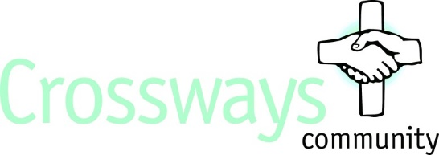

Job Description – Part-time Cleaner (15 hours)

Post Title – Cleaner

Location – London Road, Southborough, Tunbridge Wells

About us - Crossways Community is a Christian charity with a passion to see better mental health in its community. We have a proven track record in providing residential care and support for adults with acute mental health issues, giving residents valuable life skills and work experience and promoting awareness of mental health issues within schools, churches and the local community.

Purpose of the job - Ensuring we provide a clean environment for our residents and staff by providing a high-quality cleaning service and high standards of cleanliness.

Main duties of the post
- To be responsible for general cleanliness of London Road with appropriate record keeping.
- To carry out all cleaning duties as directed by the Manager or Deputy Manager to the required standard.
- To carry out deep cleaning schedule as defined by the Manager or Deputy Manager with appropriate record keeping.
- To comply with COSHH regulations and risk assessment measures relating to the use and handling of cleaning products
- To clean other areas of London Road, including where requested, residents’ personal bedrooms, bathrooms or shower rooms.
- To be aware of relevant policies and procedures of London Road.
- To respond to emergency situations in accordance with London Road policies regarding fire and accidents, determining and taking appropriate action.
- To be aware of risk assessments on the structure, fabric and environment of Crossways.
- To attend training as defined by the Manager or Deputy Manager including on Safeguarding.
- To attend morning handovers where possible.
- To be sensitive to the privacy and individual needs of the residents.
- To carry out other ad hoc duties as requested by the Manager or Deputy Manager.

Essential Qualities

- Willing to abide by Crossways’ Christian ethos.
- Good verbal and written communication skills.
- Calm, confident, methodical, patient and flexible, good interpersonal skills, and able to work as part of a team, alone and unsupervised.
- Friendly, polite and caring.
- Previous cleaning experience.
- Physically fit to undertake the role.

Additional information

- Responsible to Manager or Deputy Manager of London Road
- 15 hours a week (mornings or lunchtime desirable)
- Salary - £9.94 per hour
- The post will be subject to suitable references and an enhanced DBS check.
- Experience or knowledge of the mental health sector, whilst useful, is not essential.
- Primarily based at London Road but work may be required occasionally in other parts of Crossways site in Tunbridge Wells.

